Caption and Alt Text – 3.6.23 images from Danielle, attendance at conference.

Caption:
Staff are constantly travelling around the state of Iowa. Due to the travel, our team has adopted a small mascot. A small -green -dinosaur -mascot. His name is Monty! This week our Public Health Advocate, Danielle, traveled with Monty to the @UCEDD’s Health Fun Fair. While there, she and Monty were able to learn about the experiences of people with disabilities in healthcare.
Danielle and Monty even got to take a photo with another great Iowa mascot - @Herky The Hawk.
#WhereInTheWorldIsMonty #HerkyTheHawk #healthcare

Alt Text: Danielle, a white woman with long dark hair, takes a selfie. She is standing next to a giant bright yellow mascot. The mascot is a cartoon hawk. The mascot is holding a small green stuffed long-neck dinosaur. Everyone is smiling – even the dinosaur.
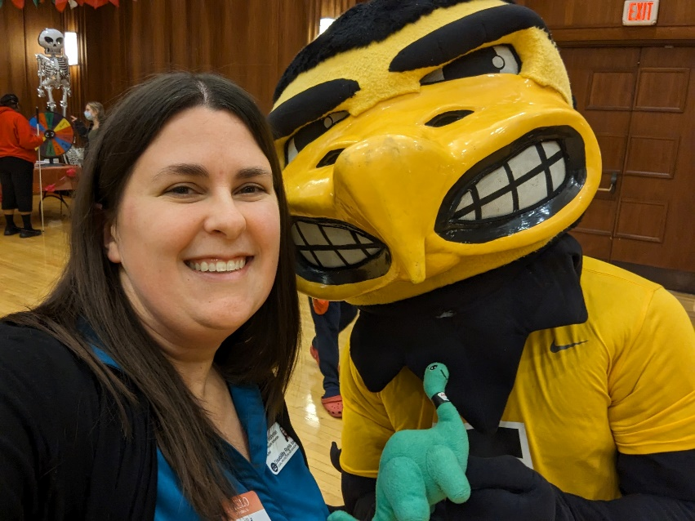
Alt Text: Herky, a bright yellow cartoon hawk mascot, is standing. He is holding a small green stuffed long- neck dinosaur. They are both smiling.
